**Press release***Trade press*

**Kautex Maschinenbau appoints Michael Müller as new global sales manager for the packaging division**

**In April Michael Müller took over the role of global sales director for packaging at Kautex Maschinenbau. Michael will be responsible for driving and managing company's sales activities in packaging division. With his degree in engineering, Kautex as world's leading system providers in blow molding technology, occupies another key role in its global leadership team. The recruitment is part of a far-reaching change process, which includes not only the realignment of the business areas but also a restructuring of the sales organization initiated last year.**

Since 2019 Kautex had already begun to expand the packaging division in addition to the automotive division, and to offer more customer-specific solutions. In order to be able to optimally raise the market potential of both segments, the company had also converted the sales organization to a division model.

CSO Andreas Lichtenauer is pleased to have the new colleague on board: "The distribution of complex customer-optimized machines and systems requires a high product and market knowledge and requires a holistic understanding of the different requirements and needs of the customer. Michael Müller has the best prerequisites for this.“ As a mechanical engineer with a focus on construction technology, he has excellent technical knowledge in mechanical engineering. Over the course of his professional career, he has also acquired decisive knowledge and Insights in PET production, most recently as sales manager at a leading supplier of injection molding technology. He knows the international packaging market very well and has valuable contacts.

The acquisition of the position of global sales director packaging closes a circle for Müller. After completing his studies in 1995, he took up his first job at Kautex as a designer. This makes him all the more pleased to be able to bring his experience gained from a rapidly changing market environment and application-centered customer focus, to the team at Kautex Maschinenbau. Michael Müller is looking forward to his new job: "The plastics industry is facing major social, technological and economic challenges. As a system provider, we have the opportunity to be an important part of the customer's value chain, from granules to the finished product.“

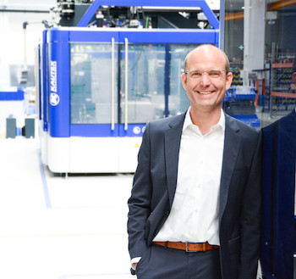

**Michael Müller**

**About Kautex Maschinenbau**Eight decades of providing its customers with innovative products and services have turnedKautex Maschinenbau into one of the world's leading companies in extrusion blow molding technology. With customers that include major automobile manufacturers and suppliers, as well as companies working in the packaging industry. All of them have come to rely on the knowledge and experience of a brand that stands for both quality and reliability. In addition to its HQ in Bonn, a Customer Service Center in Berlin and regional offices in the USA, Russia, China, Italy, India, Mexico and Malaysia, Kautex Maschinenbau operates an extensive global network of service and distribution offices. **Contact details**

**Christian Kirchbaumer**  
Head of Marketing Communications

**Kautex Maschinenbau GmbH**  
Kautexstr. 54  
53229 Bonn  
Germany

T +49 228 489370

christian.kirchbaumer@kautex-group.com